Day 1
Peripherals theory and different functions of Printers, scanners, webcams, and their connection interfaces.

1.Create a table listing 3 types of printers, 2 types of scanners, and 2 types of webcams, and for each, write one real-life use case (for example: 'Inkjet printer – printing college assignments').
1. Types of Printers, Scanners and Webcams with Real-Life Uses
A. Printers
A printer is an output peripheral that produces a physical copy of digital information, such as documents, photographs, or reports, on paper or other media.
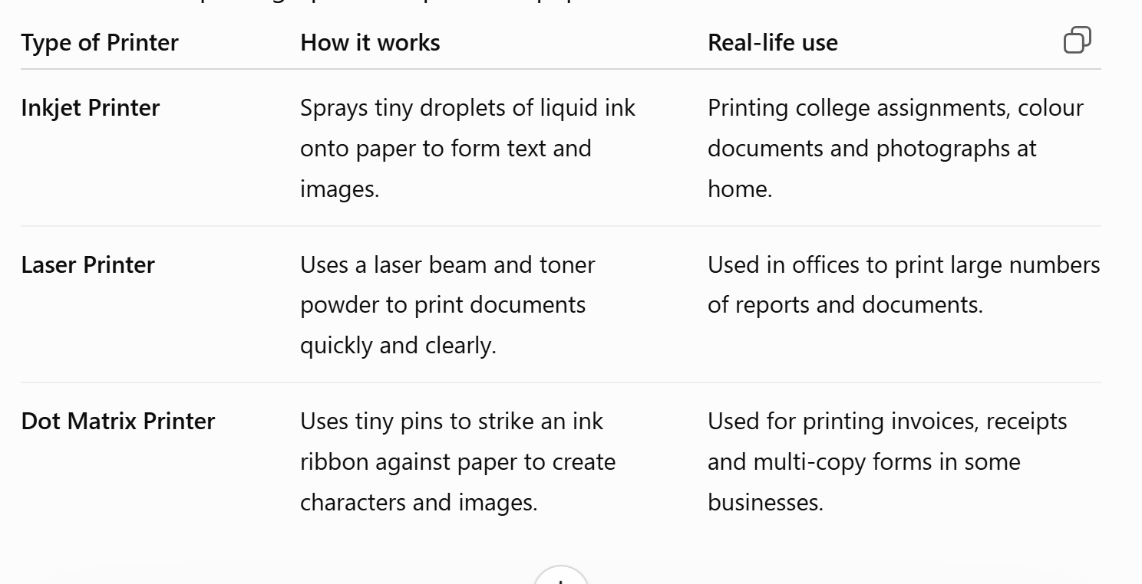
1. Inkjet Printer
- Uses liquid ink cartridges.
- Produces good-quality colour prints.
- Suitable for photographs and occasional home printing.
- Generally slower than laser printers.
Example: A student uses an inkjet printer to print college assignments and colour project images.
2. Laser Printer
- Uses toner powder instead of liquid ink.
- Uses a laser and a rotating drum to create the printed image.
- Fast and suitable for high-volume printing.
- Commonly used in offices.
Example: An office uses a laser printer to print hundreds of pages of reports every day.
3. Dot Matrix Printer
- Uses a print head containing pins.
- The pins strike an ink ribbon to produce characters.
- It can print through multi-part forms.
- It is noisier and has lower print quality than modern inkjet or laser printers.
Example: A business may use a dot matrix printer to print invoices or forms containing multiple copies.

2.Draw a labeled diagram showing how a typical home printer connects to a laptop or PC, including the connection interface used (USB, Wi-Fi, or Bluetooth).

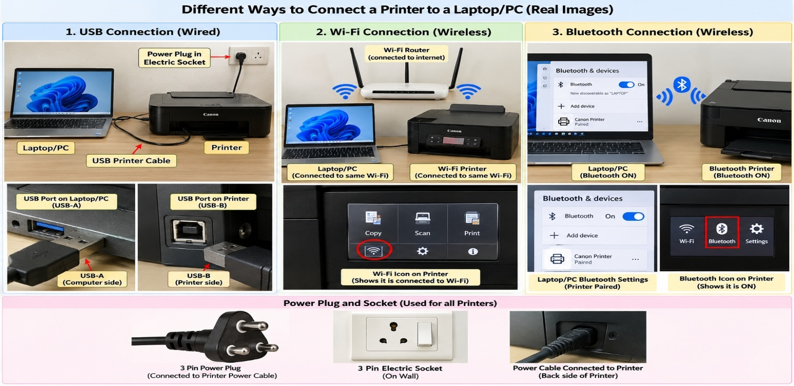
3.List three different connection interfaces (such as USB, Wi-Fi, Bluetooth) used by peripherals like printers, scanners, and webcams, and for each, name one advantage and one disadvantage.
3. Connection Interfaces: USB, Wi-Fi and Bluetooth
A connection interface is the method or technology used by a peripheral to communicate with a computer or network.
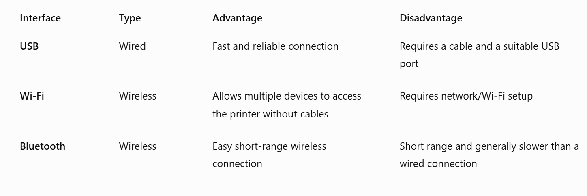
1. USB
USB = Universal Serial Bus
USB is a wired interface used to connect devices such as printers, scanners, webcams, keyboards and storage devices to computers.
Advantage:
- Reliable and generally provides a stable connection.
- No Wi-Fi network is required.
Disadvantage:
- Requires a physical cable.
- The cable length limits the distance between the computer and peripheral.
Example:
A USB printer can be directly connected to a laptop using a USB printer cable.

2. Wi-Fi
Wi-Fi is a wireless networking technology that allows devices to communicate over a wireless network.
Advantage:
- No physical cable is required between the computer and printer.
- Multiple computers and mobile devices can potentially use the same network printer.
Disadvantage:
- Requires appropriate network configuration.
- Printing can be affected if the Wi-Fi/network connection is unavailable.
Example:
A family connects a Wi-Fi printer to their home router, allowing different laptops to print to it.

3. Bluetooth
Bluetooth is a short-range wireless communication technology used to connect compatible devices.
Advantage:
- Wireless and relatively simple for short-distance connections.
- Does not require a Wi-Fi router for a direct Bluetooth connection.
Disadvantage:
- Has a shorter communication range than Wi-Fi.
- Not all printers, scanners or webcams support Bluetooth.
Example:
A Bluetooth-enabled computer can connect directly to a compatible Bluetooth printer.

4.Pick any one device you use at home or college (printer, scanner, or webcam). Write step-by-step instructions for how you would connect it to your computer, including what cable or wireless method you would use and any setup steps required.
Task 4 — Step-by-Step Instructions to Connect a Printer to a Computer
Device selected: Printer
Connection method: USB cable
Computer: Laptop/PC
A USB connection is a wired connection. The printer is connected directly to the computer using a USB printer cable.
Required items
- Printer
- Laptop/PC
- Printer power cable
- USB printer cable
- Printer driver/software, if required
- Electrical wall socket

Step 1: Place the printer
Place the printer on a stable surface near the laptop/PC.
Make sure there is enough space around the printer for paper and ventilation.

Step 2: Connect the printer to electricity
Take the printer's power cable.
Connect one end to the power input socket on the back of the printer.
Connect the other end to the electrical wall socket.
Then press the Power button on the printer.
Connection:
Electrical socket → Power cable → Printer
The power cable supplies electricity to the printer. It is different from the USB cable used for data communication.

Step 3: Identify the USB ports
A typical USB printer cable has two different ends:
Computer side — USB-A
The USB-A connector is usually the rectangular connector that goes into the USB port of the laptop/PC.
Printer side — USB-B
The USB-B connector is the squarer connector that goes into the printer's USB-B port

Step 4: Connect the USB cable
Insert the USB-A end into the USB port of the laptop/PC.
Insert the USB-B end into the USB-B port on the printer.
Do not force the connector. It should fit in the correct orientation.
Now the physical connection is:
Laptop/PC → USB cable → Printer

Step 5: Turn on the printer
Press the printer's Power button.
Wait for the printer to finish its startup process.
The printer may take a few seconds to become ready.

Step 6: Let Windows detect the printer
On a Windows computer, open:
Settings → Bluetooth & devices → Printers & scanners
Windows may automatically detect the connected printer.
If the printer appears in the list, select it.

Step 7: Install the printer driver if required
A printer driver is software that allows Windows to communicate properly with the printer.
Sometimes Windows installs the driver automatically.
If it does not:
- Identify the printer's manufacturer and model.
- Download the appropriate driver/software from the manufacturer's official website.
- Install it.
- Follow the instructions displayed on the screen.

Step 8: Add or select the printer
If Windows does not automatically add the printer:
Settings → Bluetooth & devices → Printers & scanners → Add device
Select the detected printer and complete the setup.

Step 9: Print a test page
Open a document.
Select:
File → Print
Choose your connected printer.
Click Print.
If the printer prints the document correctly, the setup is successful.
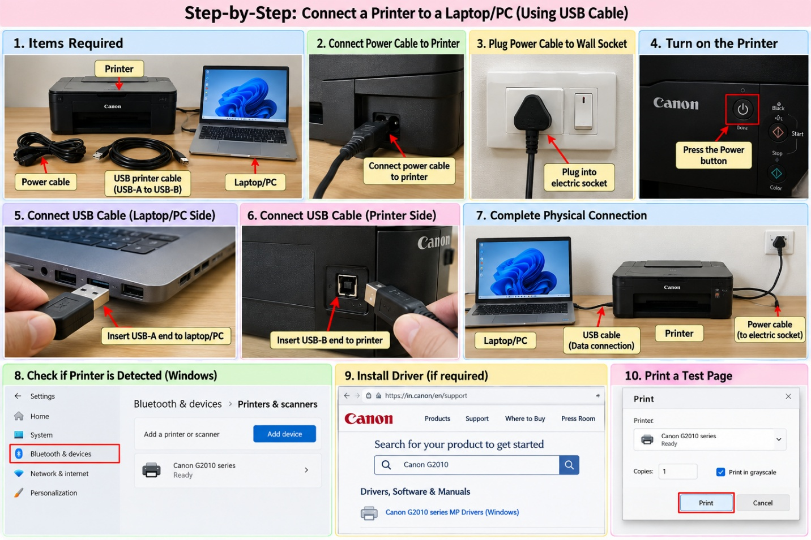
🔌 How it works
USB-A → USB cable → USB-B
- USB-A end → goes into the USB port on the laptop/PC
- USB-B end → goes into the USB-B printer port

